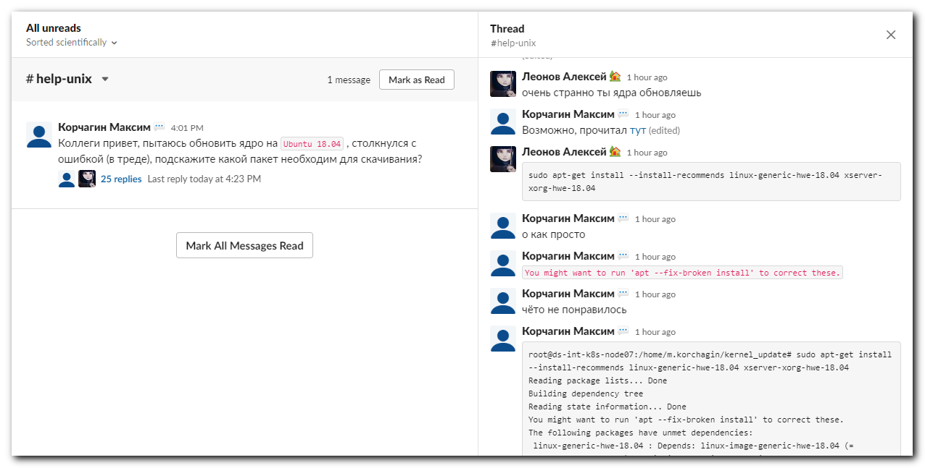

# 20200814
Леонов Алексей 1 hour ago
sudo apt-get install --install-recommends linux-generic-hwe-18.04 xserver-xorg-hwe-18.04

